**EXPERIMENT NO:6**

Applying DDL Commands(Data Manipulation commands)

* Insert
* Update
* Delete
* Select

**Insert :-**

CREATE TABLE Students (st_id int, st_name varchar(25), st_ph_no varchar(10));

Desc Students;

insert into Students values(201, 'som', '1234567890');

INSERT into Students values(202, 'ram', '0987654321');

INSERT into Students values(203, 'rom', '1368097321');

INSERT into Students values(204, 'jun', '1357986420');

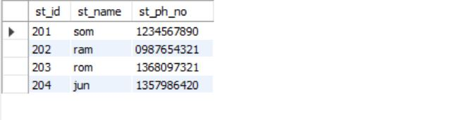

update Students set st_name='ramu' where st_id='203';

select *from Students;

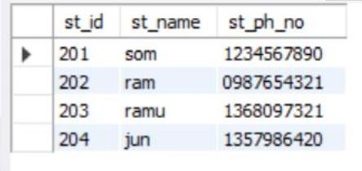

delete from Students where st_id=201;

select * from Students;

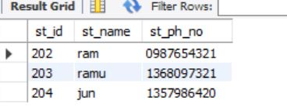

select st_name from Students;

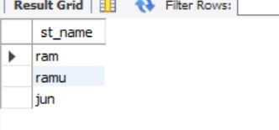

select distinct st_ph_no, st_id from Students;

